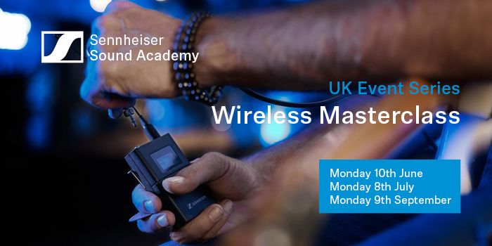
Sennheiser launches new series of Sound Academy Wireless Masterclasses

Starting June 10th, attendees will be able to elevate their skills and stay ahead of the curve with Sennheiser’s in-depth exploration of RF and next-generation wireless technologies

Marlow, 4 June 2024 – Sennheiser is excited to announce the launch of new Sound Academy workshops, starting in June, at their new UK office in Marlow, Buckinghamshire. Marcus Blight, the UK's Technical Applications Engineer at Sennheiser, will lead these sessions.

The comprehensive program delves into the science and application of wireless audio, equipping participants with essential knowledge and expertise. Targeted at audio engineers, sound designers, live event professionals, RF technicians, installers, and system integrators, these masterclasses offer hands-on experience with the latest wireless technologies from industry experts.

“We’re pleased to bring new dates for our Sound Academy Wireless Masterclasses, where attendees will gain practical skills through interactive sessions, participate in dedicated Q&A sessions, and network with fellow professionals, all while enhancing their wireless audio expertise,” says Blight.

Available Dates:
Monday, 10th June 2024
Monday, 8th July 2024
Monday, 9th September 2024

For anyone looking to stay ahead in wireless audio technology, register via the link here. Space is limited, so secure your spot today.

(The End)

About the Sennheiser brand
We live and breathe audio. We are driven by the passion to create audio solutions that make a difference. Building the future of audio and bringing remarkable sound experiences to our customers – this is what the Sennheiser brand has represented for more than 75 years. While professional audio solutions such as microphones, meeting solutions, streaming technologies and monitoring systems are part of the business of Sennheiser electronic GmbH & Co. KG, the business with consumer devices such as headphones, soundbars and speech-enhanced hearables is operated by Sonova Holding AG under the license of Sennheiser.

www.sennheiser.com
www.sennheiser-hearing.com

Local Press Contact
Sennheiser electronic GmbH & Co. KG
Maik Robbe
Communications Manager EMEA
T +49 (0) 5130 / 600 1028
Maik.Robbe@sennheiser.com

